Mini Game

Objective:

Catch all the rotating cubes.

How to play:

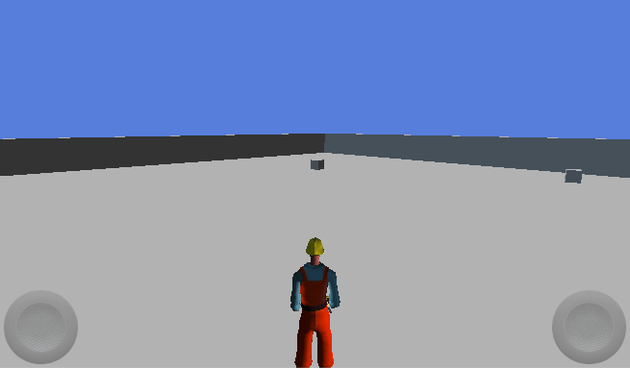

**Play!**

**Move up to move the player.**

**Press 2 times and keep pressing while moving player to run.**

**Move up to make player jump.**

**Mini Game**

**Catch all the cubes.**

**How to play:**



**Move left and right to turn the camera.**